**BATCH NUMBER : B8-2A4E**

**PROCEDURE FOR IBM WATSON IOT & DEVICE CREATION:**

**To connect IOT devices with IBM platform**

Step 1: Go to IBM cloud Platform and click catalog. Now select services and then select Internet Of Things and Internet of Things Platform.

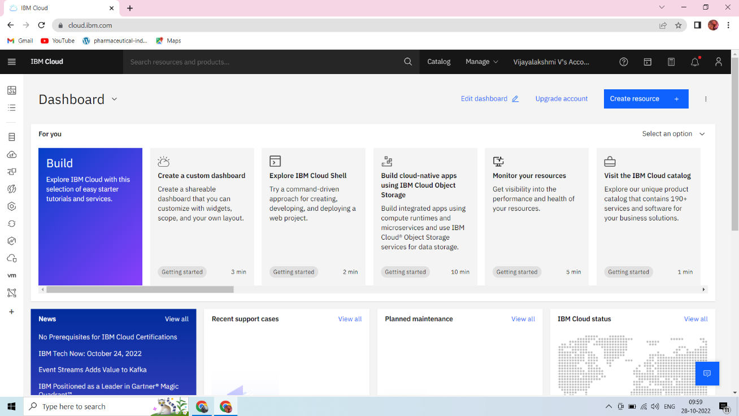

Step 2: Now you will be redirected to a new page. Here, select the region, pricing plan and service name and click create.

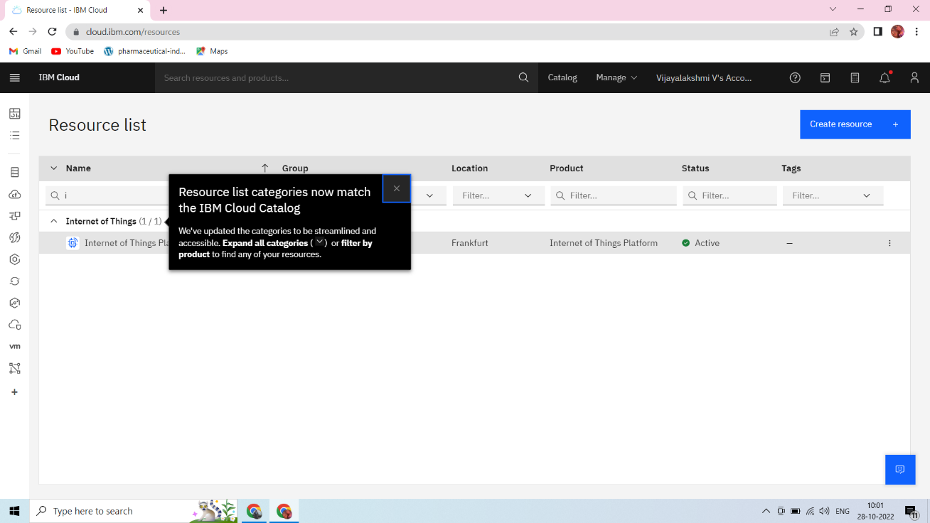

Step 3: As a next step you’ll be redirected to the page Internet Of Things Platform-Here click launch.

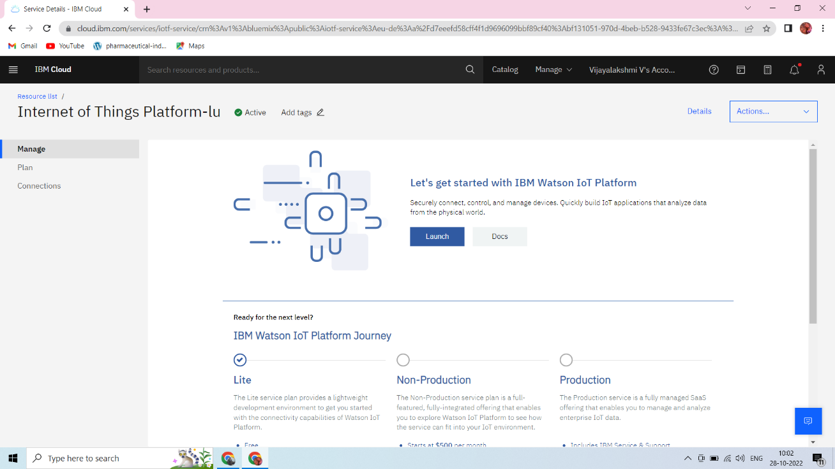

Step 4: IBM Watson IOT Platform will be launched. Click on sign in and login using your IBM registered credentials.

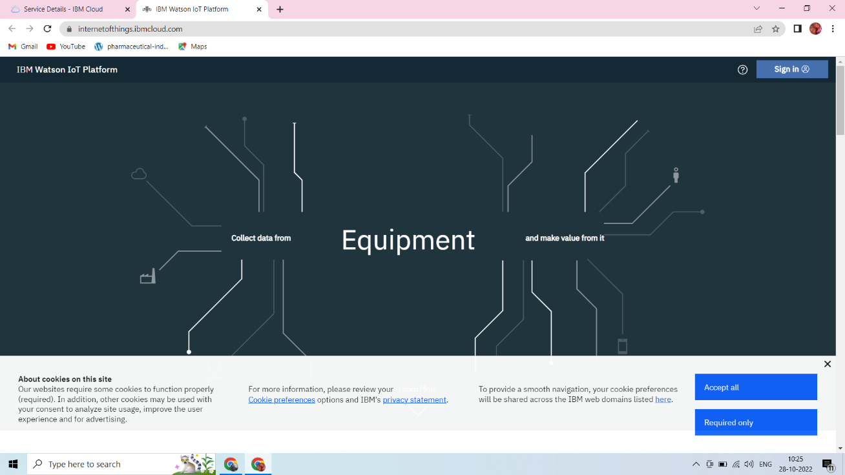

### Step 5: Under devices, click create device. Enter the device details and click finish.

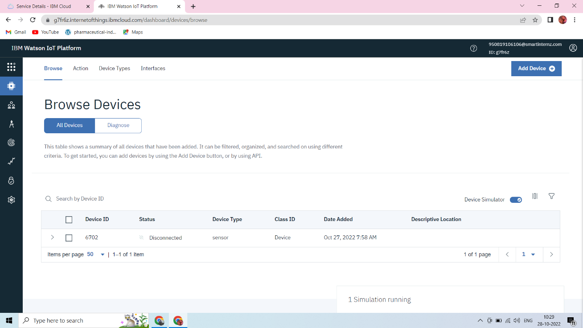

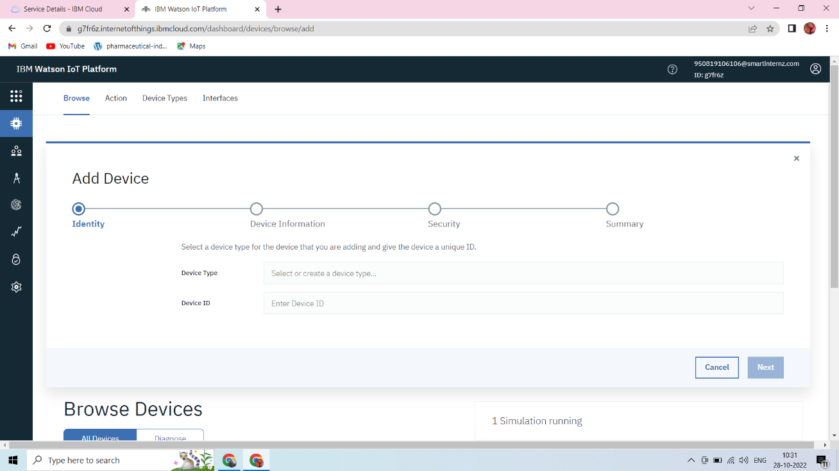

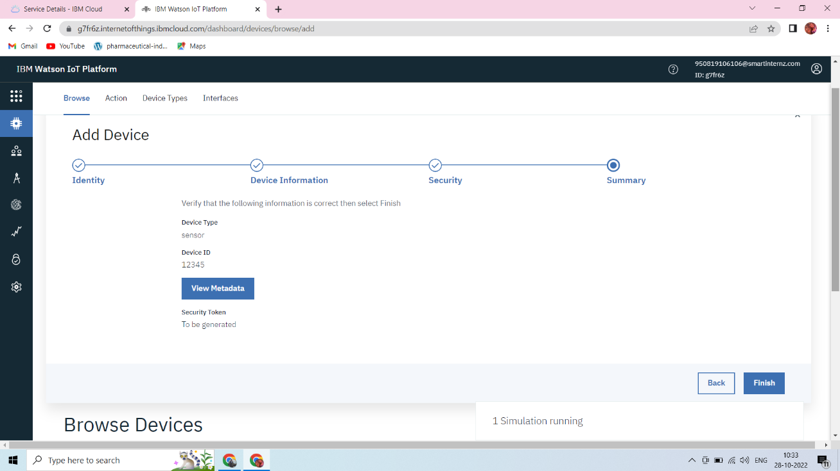

### Step 6: Thus the IOT device is created. Copy the device credentials into a notepad.

### 

### 